Assumption tests found in output:

* Box’s M (found before the multivariate box) – multivariate homogeneity
* Mauchly’s (found after the multivariate box) – test of Sphericity
* Levene’s (found after the within subjects box) – test of univariate homogeneity – useful if your Box’s M is bad, so you can see which DV is the issue.

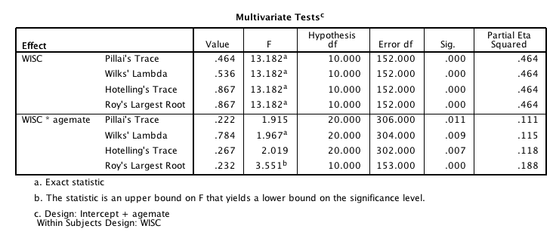Flatness: Effect of the *repeated measures* variable (time) found in the Multivariate box.

Parallelism: Effect of the *interaction* found in the Multivariate box.

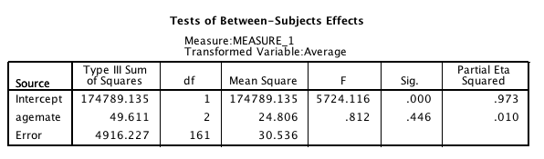Levels: Effect of the *between subjects* variable (groups) found in the between subjects box.

Talk about all this stuff in the first paragraph! You must list all three! Then you walk through a post hoc test depending on what effects were significant.